**Department of Computer Engineering**

**Academic Term: First Term 2023-24**

# Class: T.E /Computer Sem – V / Software Engineering

|  |  |
| --- | --- |
| **Practical No:** | **2** |
| **Title:** | **Implementing Project using Scrum method on JIRA Tool** |
| **Date of Performance:** | **01/08/2023** |
| **Roll No:** | **9625** |
| **Team Members:** | Aditya Dhikale, Mohtashim Ali, Siddhant Murade  (9531) (9644) (9625) |

**Rubrics for Evaluation:**

|  |  |  |  |  |  |
| --- | --- | --- | --- | --- | --- |
| **Sr.**  **No** | **Performance Indicator** | **Excellent** | **Good** | **Below Average** | **Total Score** |
| 1 | On time Completion &  Submission (01) | 01 (On  Time ) | NA | 00 (Not on  Time) |  |
| 2 | Theory Understanding(02) | 02(Correct  ) | NA | 01 (Tried) |  |
| 3 | Content Quality (03) | 03(All used) | 02 (Partial) | 01(rarely followed) |  |
| 4 | Post Lab Questions (04) | 04(done well) | 3 (Partially  Correct) | 2(submitted) |  |

**Signature of the Teacher:**

**Department of Computer Engineering**

**Academic Term: First Term 2022-23**

# Class: T.E /Computer Sem – V / Software Engineering

**Signature of the Teacher:**

1. Creating Project

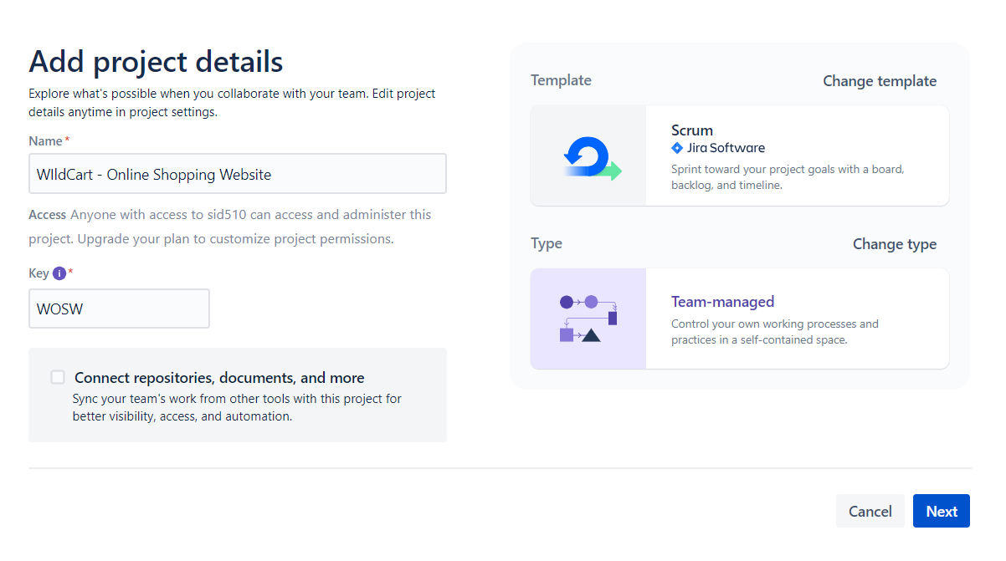

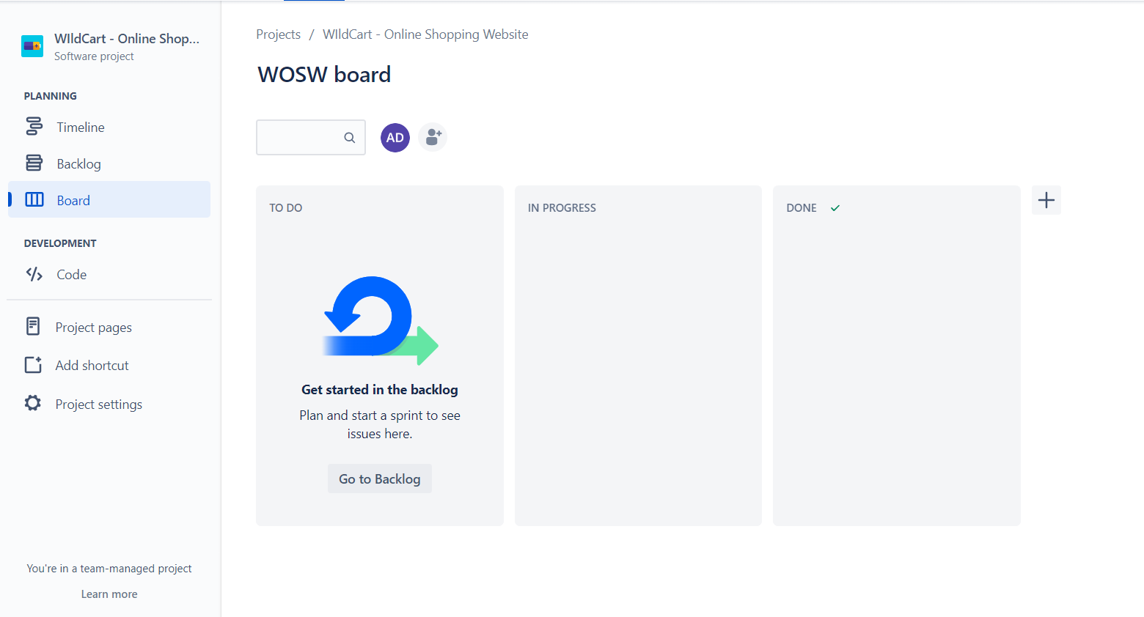

1. Creating an Epic

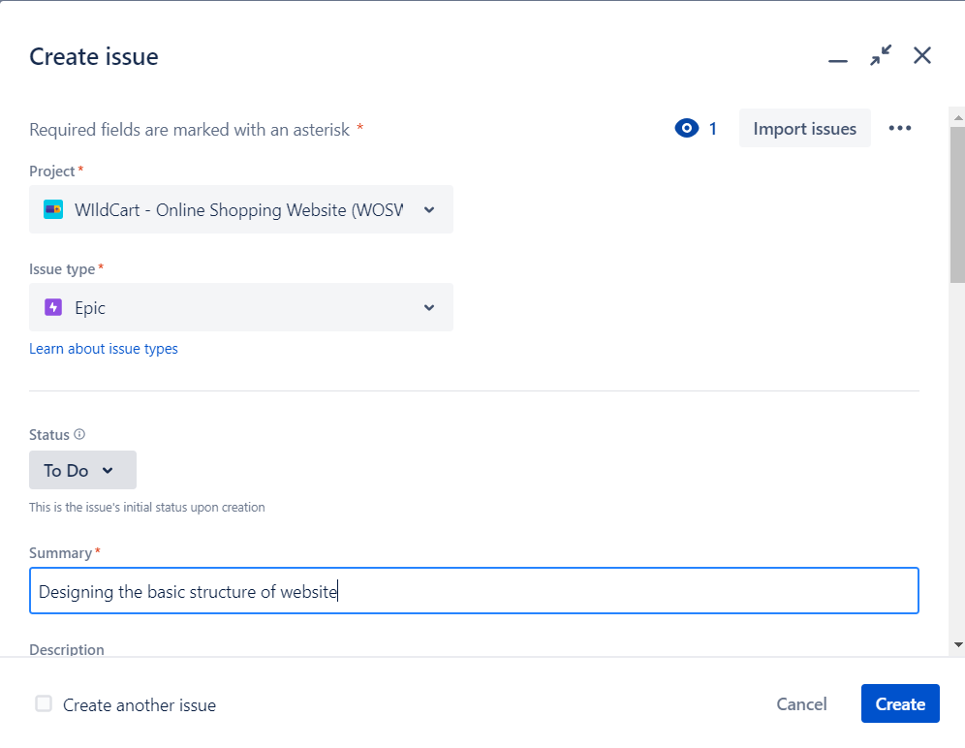

1. Creating Story

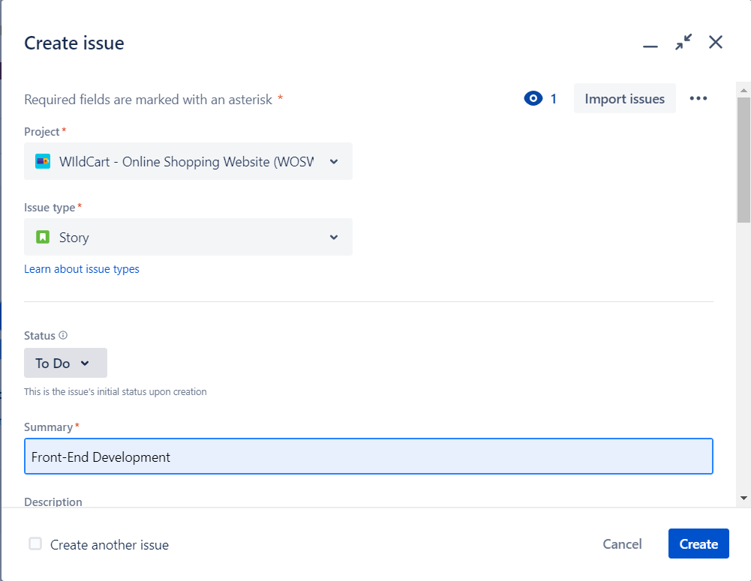

1. Assigning Subtasks

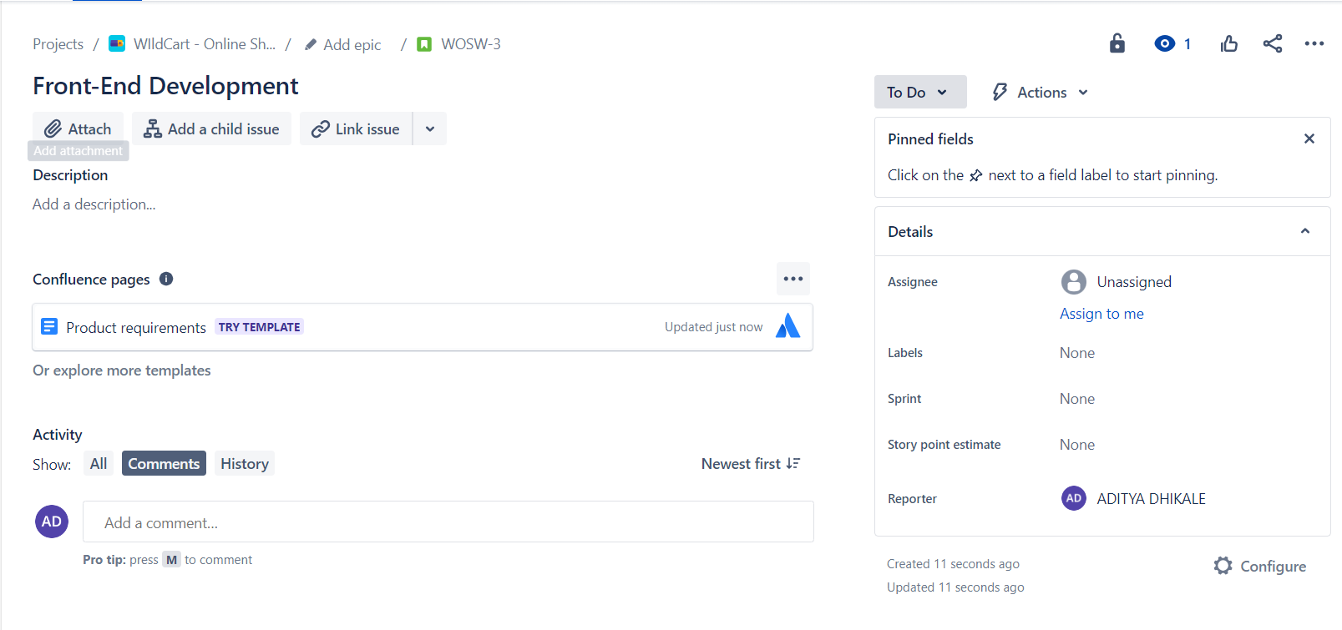

1. Sprint

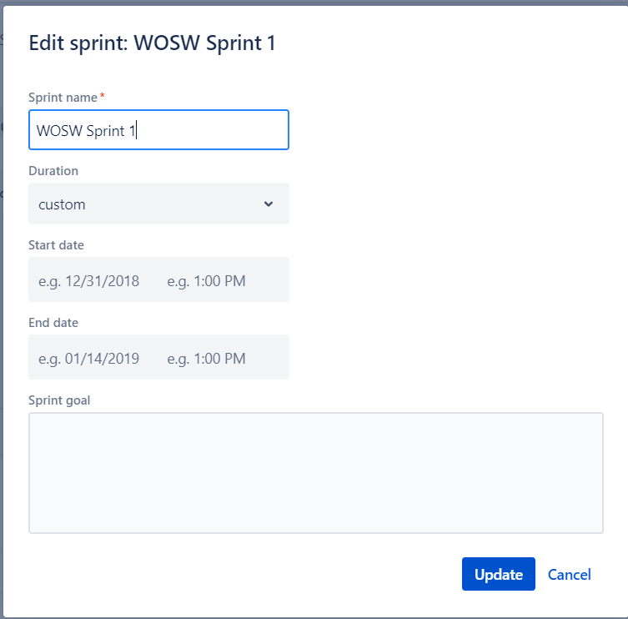

1. Project

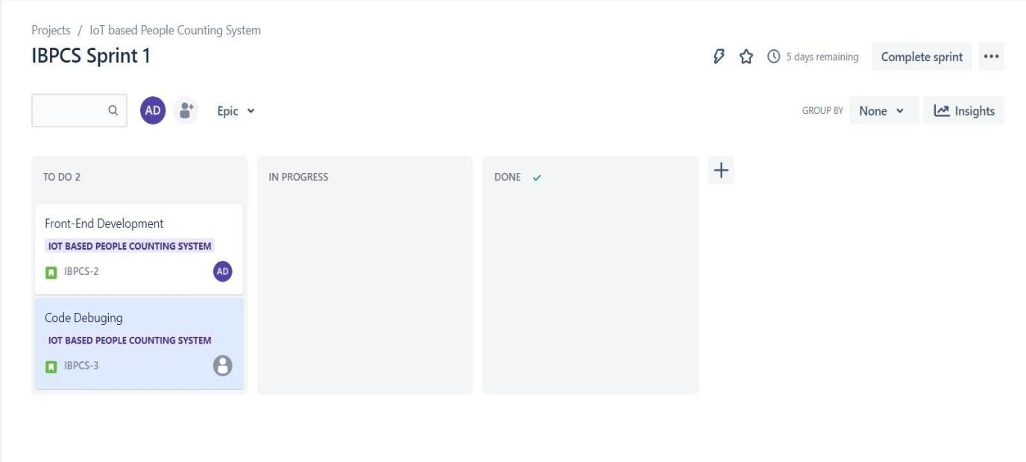

Postlab:

1. Assess the effectiveness of the Scrum framework for managing software development project compared to traditional project management methodologies?

Sol:- The main difference between scrum and traditional [project management methodologies](https://blog.planview.com/the-best-project-management-methodologies-for-marketing-projects) can be summed up as fixed scope vs. iterative decision making. Classic project management calls for project managers to look at the development as a whole whereas Scrum has no problem dividing it up into segments. Unlike classic project management methods, Scrum focuses more on personal responsibility.

|  |  |
| --- | --- |
| Scrum Fr**amework management** | Traditional Project Management |
| Emphasizes flexibility and adaptability | Emphasizes planning and predictability |
| Prioritizes customer satisfaction and working software | Prioritizes following a strict plan and meeting project requirements |
| Linear | Iterative |
| Large-scale | Small and Medium scale |
| Life cycle model | Evolutionary delivery model |
| Self-organizing teams | Hierarchically organized teams |
| Cross-functional teams | Functionally divided teams |

1. Analyse a Sprint Backlog in JIRA and identify any potential bottlenecks or issues that might hinder the team's progress during the sprint?

Sol:- The backlog of a Scrum board shows the issues for your project grouped into a backlog and sprints. In the Scrum backlog, you can create and update issues, drag and drop issues to rank them, or assign them to sprints, epics, or versions, manage epics, and more. You'd typically use the Scrum backlog when building a backlog of issues, planning a new version, and planning a sprint. An issue will only be visible in the Scrum backlog if:

* 1. the issue isn't a subtask,
  2. the issue matches the board's saved filter,
  3. the issue's status maps to one of the board's columns (but not the Donecolumn), and
  4. there's at least a status being mapped to the right-most column. For example, if you have the columns To Do*,*In

Progress,and Done*,*ensure that you have a status mapped to In Progressat least. If you map all the statuses to the first (To Do) column, you won't see any issues in the Scrum backlog.

1. Evaluate the role of the Scrum Master in handling conflicts within the development team and resolving impediments to maintain a smooth project flow?

Sol:- A Scrum Master (Scrum Master), popularly known as the “servant leader” is a coach, motivator and leader of an Agile team. The role of a Scrum Master is to educate the team on Agile processes and help team members follow Scrum practices religiously. A good Scrum Master helps to establish a highperforming team dynamic, a continuous flow, and an exponential improvement in processes. They are required to play a pivotal role and are responsible for the progressive development of a Scrum team.  The Scrum Master collaborates both with the Product Owner (PO) who focuses on building the right product, and the

development team that focuses on building the product right. A Scrum Master’s job is essentially to help everyone understand and imbibe Scrum values, principles, and practices and get the best product out to the customer. To facilitate conflict management in Scrum teams, Scrum masters can create and maintain a safe and positive team environment, model and promote behaviors and attitudes that foster constructive conflict, educate and empower the team to prevent, minimize, and resolve conflict, mediate and facilitate the conflict resolution process when needed, provide feedback and guidance to the team and the individuals on how to improve their conflict management skills, and encourage and support the team to leverage conflict for improvement.